Device Registration Subsystem 3.0.0

User Guide (Individual)

DRS-User-Guide-Individual-3.0.0

November 02, 2020

Revision history

|  |  |  |
| --- | --- | --- |
| Revision | Date | Description |
| A | November 2020 | Release 3.0.0 |

# Contents

1. Introduction 5

1.1. Purpose 5

1.2. Supported Desktop Browsers 5

1.3. Supported Mobile Browsers 6

1.4. Definitions, Acronyms, and Abbreviations 6

2. System Description 7

3. System Navigation 11

3.1. Registration 11

3.2. Login Screen 14

3.3. Portal Sections 15

3.4. Notification Alerts 16

3.5. Dashboard 17

3.6. System Instructions 18

3.7. Device Registration (Normal Application Process) 20

3.8. Device Registration (Automated Application Process) 29

3.9. Search Request 41

**Figures**

Figure 1 - Account Registration 11

Figure 2 - Personal Information 12

Figure 3 - User Role 13

Figure 4 - Login Screen 14

Figure 5 - Portal Sections 15

Figure 6 - Notification Alert Icon 16

Figure 7 - Dashboard Screen 17

Figure 8 - System Instructions (i) 18

Figure 9 - System Instructions (ii) 19

Figure 10 - Device Registration 20

Figure 11 - Add Device (i) 21

Figure 12 - Add Device (ii) 22

Figure 13 - Delete Device (i) 23

Figure 14 - Delete Device (ii) 24

Figure 15 - Type IMEI 25

Figure 16 - Device Model Description 26

Figure 17 - Approval Documents 27

Figure 18 - Request Status 28

Figure 19 - Device Registration 29

Figure 20 - Add Device (i) 30

Figure 21 - Add Device (ii) 31

Figure 22 - Delete Device (i) 32

Figure 23 - Delete Device (ii) 33

Figure 24 - Type IMEI 34

Figure 25 - Device Model Description 35

Figure 26 - Request Status 36

Figure 27 - IMEI Association (i) 37

Figure 28 - IMEI Association (ii) 38

Figure 29 - IMEI De-Association (i) 39

Figure 30 - IMEI De-Association (ii) 40

Figure 31 - Search Request(s) 41

Figure 32 - Action Tab(s) 42

Figure 33 - View Request (i) 43

Figure 34 - View Request (ii) 44

Figure 35 - Download Report Button 45

Figure 36 - Search Filters (i) 46

Figure 37 - Search Filters (ii) 47

**Tables**

Table 1 - Supported Desktop Browsers 5

Table 2 - Supported Mobile Browsers 6

Table 3 - Definition, Acronyms, and Abbreviations 6

Table 4 - System Description 7

# **Introduction**

Device Registration Subsystem (DRS) is the subsystem of Device Identification, Registration & Blocking System (DIRBS). It provides a platform for individual(s) to request for device registration, association and de-association with unique identity.

Individuals are people who are not licensed to import devices into the country, but are allowed to import a small number of devices via personal import exceptions.

The Device Identification, Registration & Blocking System (DIRBS) is a country-wide system deployed in cooperation between the country regulator, operators in that country, and a technology partner that supports deployment. The system checks, identifies, and discourages non-compliant devices by verifying the installed base of devices currently active in a market and continuing to monitor as new devices are activated.

DIRBS can verify that:

* Devices have properly allocated identifiers and type approval
* Devices are not duplicated or stolen
* Device importation takes place through legal channels

## **Purpose**

This document is intended to give assistance to the user to use the Device Registration Subsystem (DRS).

## **Supported Desktop Browsers**

Table 1 - Supported Desktop Browsers

|  |  |
| --- | --- |
| **Name** | **Version** |
| Internet Explorer | 11.719 |
| Firefox | 82.0.2 |
| Chrome | 86.0 |
| Safari | 13.1.2 |
| Edge | 87.0 |

## **Supported Mobile Browsers**

Table 2 - Supported Mobile Browsers

|  |  |
| --- | --- |
| **Name** | **Version** |
| Chrome | 86.0.4 |
| UC Browser | 13.3.2 |
| Opera (Android) | 60.3 |
| Opera Touch (iOS) | 2.5.1 |
| Safari | 13.1.2 |
| Samsung Internet | 13.0.1 |
| Android | 10 |

## **Definitions, Acronyms, and Abbreviations**

Table 3 - Definition, Acronyms, and Abbreviations

|  |  |
| --- | --- |
| **Term** | **Definition** |
| **DIRBS** | **Device Identification Registration and Blocking System** |
| IAM | Identity Access Management System |
| DRS | Device Registration Subsystem |
| MSISDN | Mobile Subscriber Integrated Services Directory Number |
| IMEI | International Mobile Equipment Identity |
| IMSI | International mobile subscriber identity |
| TAC | Type Allocation Code |

# 

# **System Description**

Table 4 - System Description

|  |  |
| --- | --- |
| Feature/Sections | ****Explanation**** |
| Registration | * **Allows user to register his/her account, associate and de-associate device(s).** |
| Login Screen | * To access the system, authorized user first needs to enter his/her credentials on login page, this login page authenticate user from the IAM and redirects user to DRS. |
| Portal Sections | The portal is divided into the following sections.   * **Header**   **Header section displays name of the system and it contains following features.**   * **Language Selection Drop-Down**   **Allows user to change the language of system in English, Spanish and Indonesian.**   * **User Profile Drop-down**   **Displays the user name with logout functionality.**   * **Notification Alert Icon**   **Generates the notification whenever user (reviewer) Updates/modifies status of the request (i.e. Approved, Information Requested, Rejected).**   * **Navigation Panel**   Navigation Panel contains main navigation menu through which user can navigate the whole system.   * **Main Content Area**   Main Content Area contains all the content to be displayed and actions to be performed for respective feature.   * **Breadcrumbs**   Breadcrumbs allow user to keep track of their location within the system.   * **Footer**   Footer contains the software version and copyrights statement. |

|  |  |
| --- | --- |
| **Feature/Sections** | **Explanation** |
| Dashboard | * The dashboard displays total count of Pending Reviews, Awaited Documents, In-Review Requests and Information Requested requests. It also displays the recent pending requests along with their details. |
| Device Registration | Facilitate user to register their device(s) by completing following three steps  Basic Registration Details  Device Model Description  Approval Documents |
| Required Input(s) for Basic Registration | **Device Count**  Takes the total number of devices as input.  **Number of IMEIs per Device**  Takes total number of IMEIs entered for each device as input.  **Device IMEIs**  **Tab-delimited File**  User can add up to 10,000,000 devices with 5 IMEIs per device.  **Webpage input**  User can add up to 10 devices with 5 IMEI per device.  **Manufacturing Details**  Allows user to select the manufacture location of the device (i.e. local or overseas). |
| Required Inputs for Device Model description | **Brand**  Takes brand name of the device as input. Enter the brand name of device to be registered.  **Model Name**  Takes the model name of device as input. Enter model name of device to be registered.  **Model Number**  Takes the Model number of the device as input. Enter model number of the device to be registered.  **Device Type**  Allows user to select type of the device (i.e. smart phone, tablet, dongle, router, Feature phone etc.) from drop-down menu.  **Operating System**  Takes the operating system (i.e. android, IOS) of device as input. Enter the operating system of device to be registered.  **Radio Access Technology**  Allows user to select the radio-based technologies i.e. 2G, 3G, 4G that your device supports. |
| Approval Documents | Three types of approval documents are required for device registration  Shipment Document  Authorization Document  Certificate Document |
| Association | Facilitates user to associate particular IMEIs with his/her unique identity |
| De-Association | Allows user to de-associate IMEIs from his/her identity |
| Search Requests | Allows user to search a particular request by applying different filters i.e. request ID, request status, device IMEI, create date, last updated, brand, model name, model number, device type, operating system, technologies, device count, number of IMEIs per device, manufacturing location |
| Request Status | * **New Request**   Add/Verify details of the device model.   * **Awaiting Documents**   Approval documents are required to be uploaded.   * **Pending Review**   Request is not yet assigned to any authorized entity.   * **In Review**   Request has been assigned to authorize entity.   * **Information Requested**   Request has some missing information.   * **Approved**   Request has been approved by authorized entity.   * **Rejected**   Request has been rejected by authorized entity due to invalid information.   * **Closed**   Request has been closed by the user(importer). |

# **System Navigation**

## **Registration**

To register user account, take the following steps.

1. Click on “Register” link.

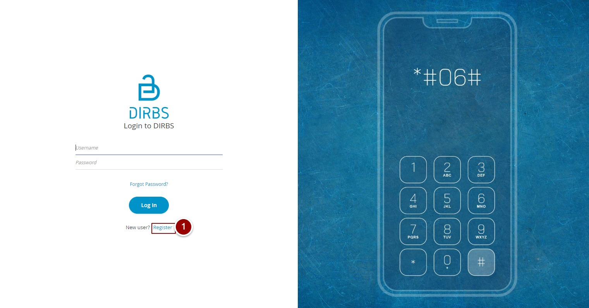

Figure 1 - Account Registration

1. Enter all the information i.e. First name, Last name, National Identity number, Email, Username, Password and Confirm Password.
2. Click on “Register Button”

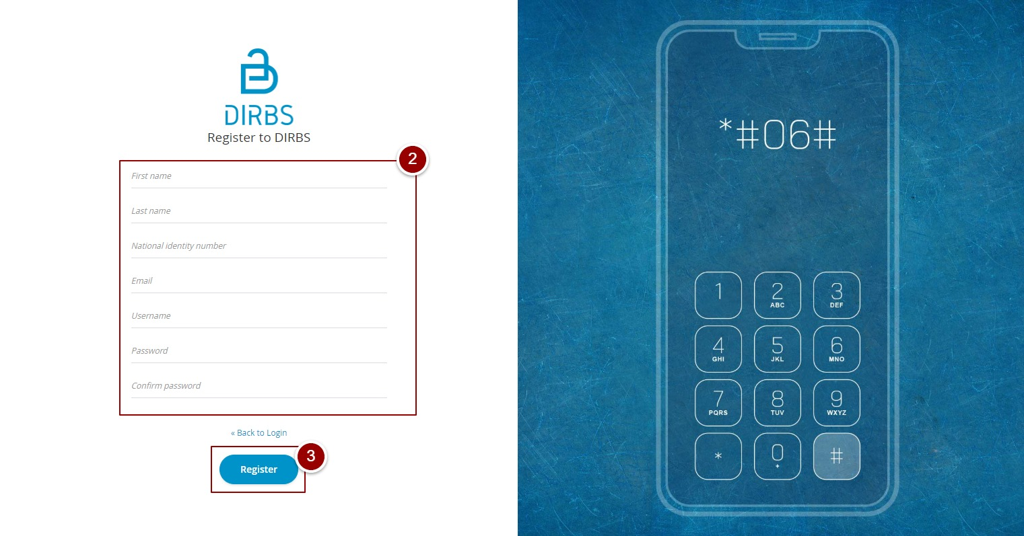

Figure 2 - Personal Information

1. Select user group “DRS INDIVIDUAL”
2. Click on “Submit” button

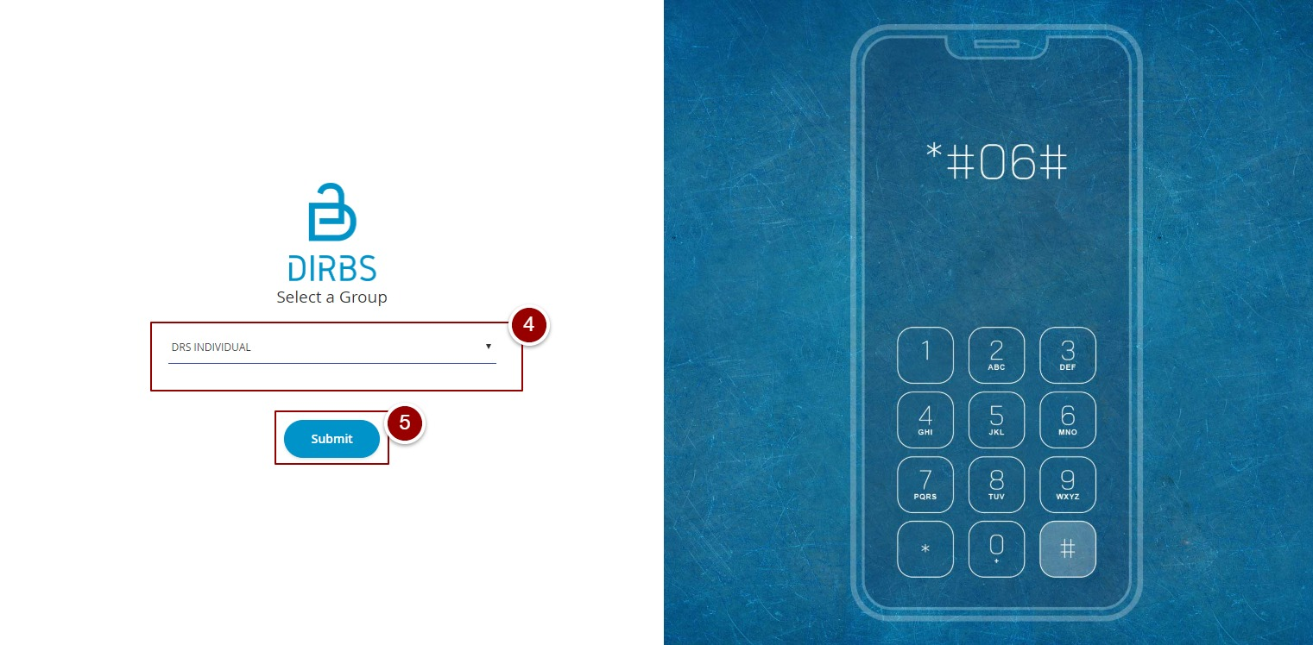

Figure 3 - User Role

## **Login Screen**

1. **Enter your credentials i.e. Username and Password.**
2. **Click on the “Log in” button.**

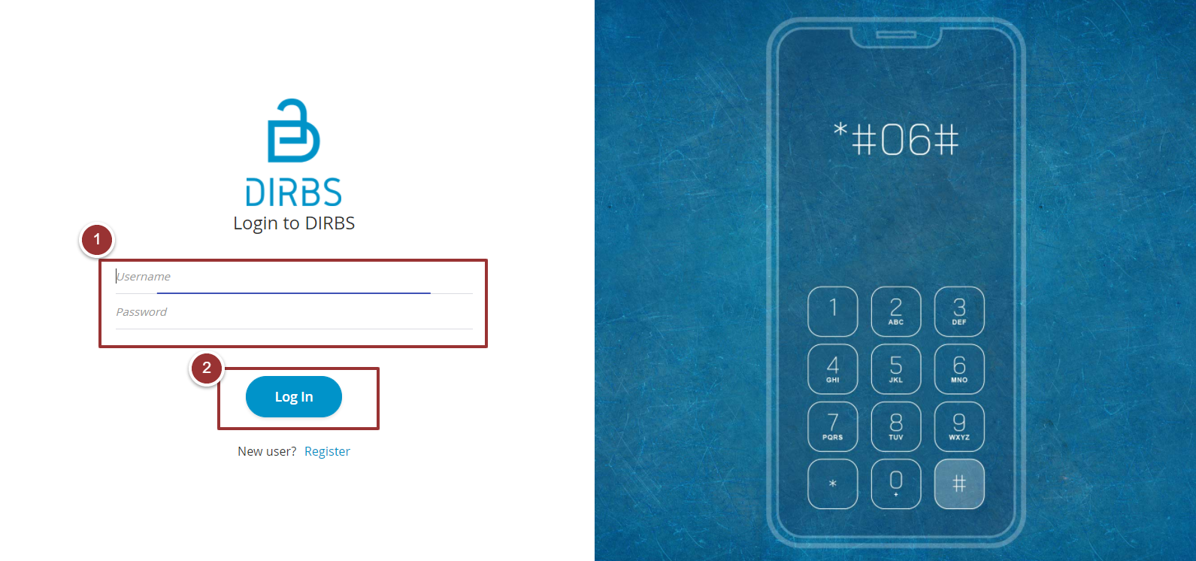

Figure 4 - Login Screen

## **Portal Sections**

The portal screen is divided into following sections.

1. **Header** section displays name of the system, a dropdown menu for language selection, notification alert icon and name of logged in user with logout functionality.
2. **Main Navigation Panel** helps user to navigate the system.
3. **Breadcrumbs** is a navigational aid in UI.
4. **Main Content Area** contains all relevant information related to the respective feature/option.
5. **Footer** contains version and copyright information of the system.

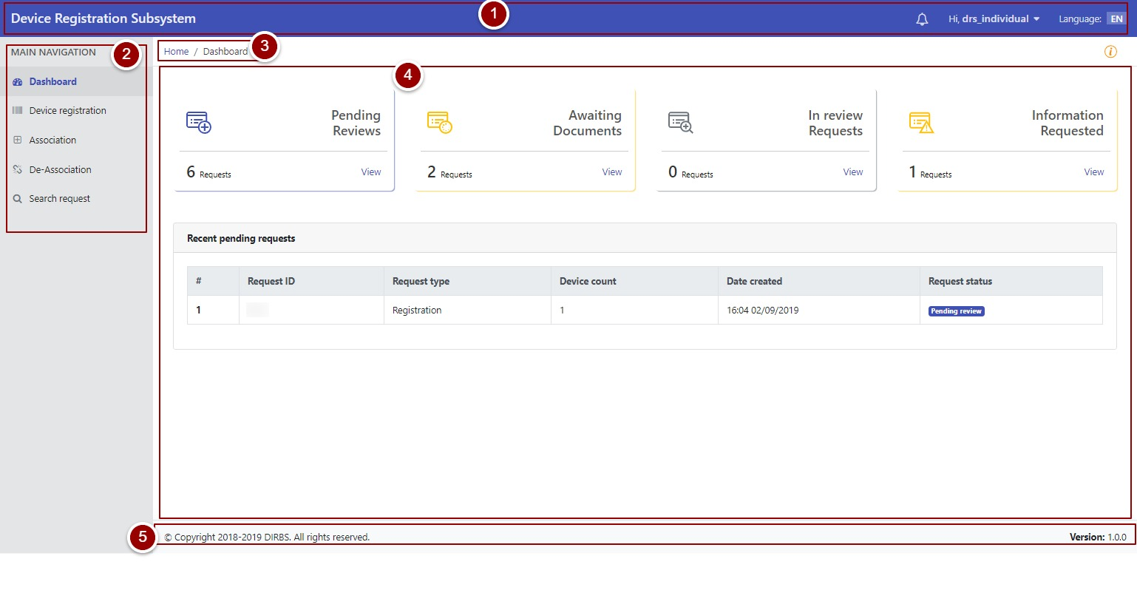

Figure 5 - Portal Sections

## **Notification Alerts**

1. To view notification(s), click on the notification alert icon. Further, application status notification will also be shown. 

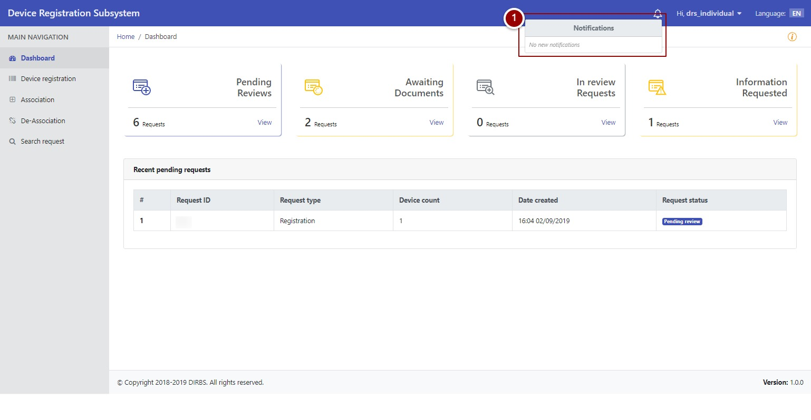

Figure 6 - Notification Alert Icon

## **Dashboard**

By clicking on “login” button, user will be redirected to dashboard screen that displays the total count of “Pending Reviews”, “Awaited Documents”, “In-Review Requests” and “Information Requested” requests. It also displays recent pending requests along with their details.

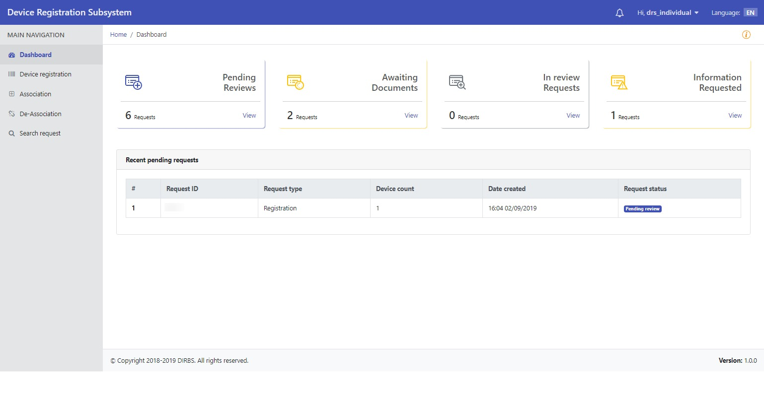

Figure 7 - Dashboard Screen

By clicking on any recent pending request, user will be redirected to that particular request.

## **System Instructions**

1. To view instructions of the system, click on icon

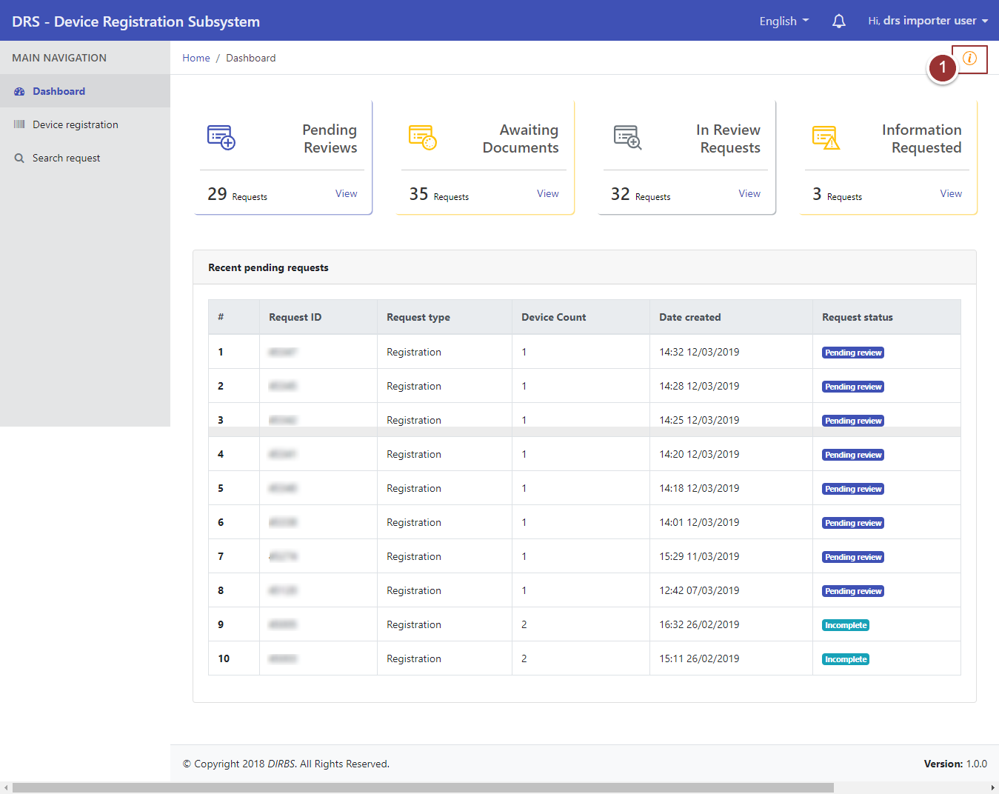

Figure 8 - System Instructions (i)



By clicking on instructions icon, a pop up will appear that display instructions for user.

1. Click on “Close” button to proceed further.

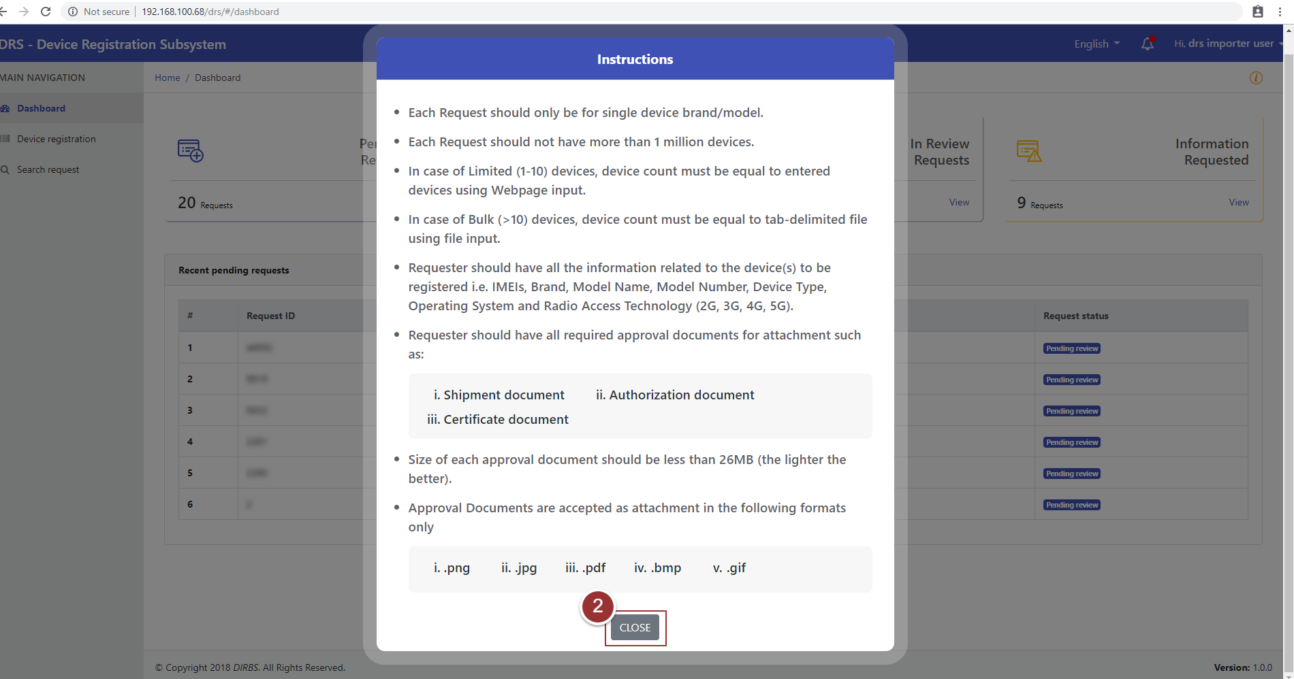

Figure 9 - System Instructions (ii)

## **Device Registration (Normal Application Process)**

1. To request for device registration, click on “Device Registration” tab under “Main Navigation” heading.
2. Enter basic registration details (i.e. Device Count, Number of IMEIs per Device, Device IMEIs and Manufacturing location).

**Note**: All field(s) are mandatory.

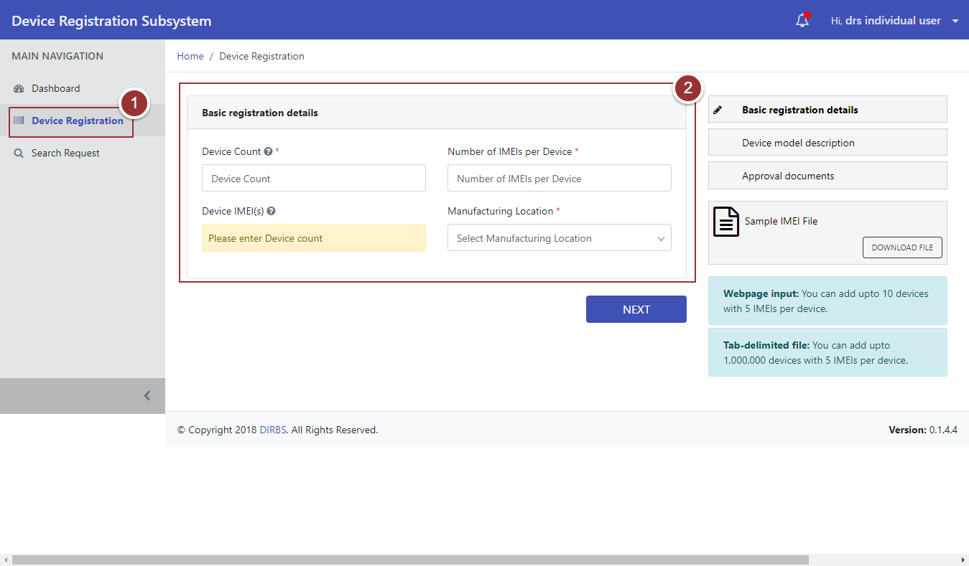

Figure 10 - Device Registration

1. To add IMEI of the device, click on “Add Device” button.

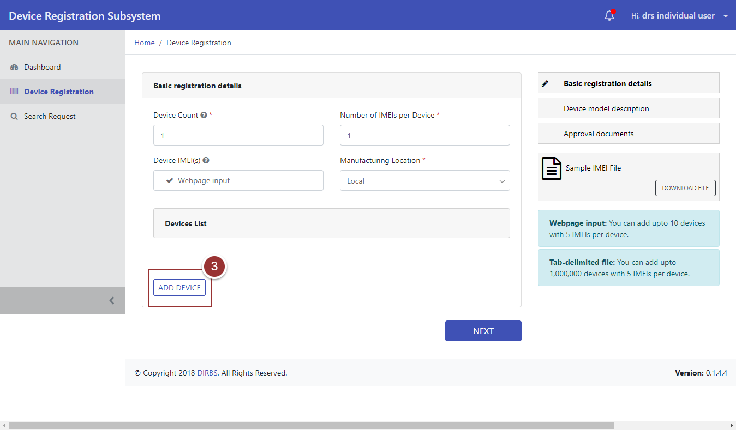

Figure 11 - Add Device (i)

1. Now, type and re-type IMEI in respective fields.

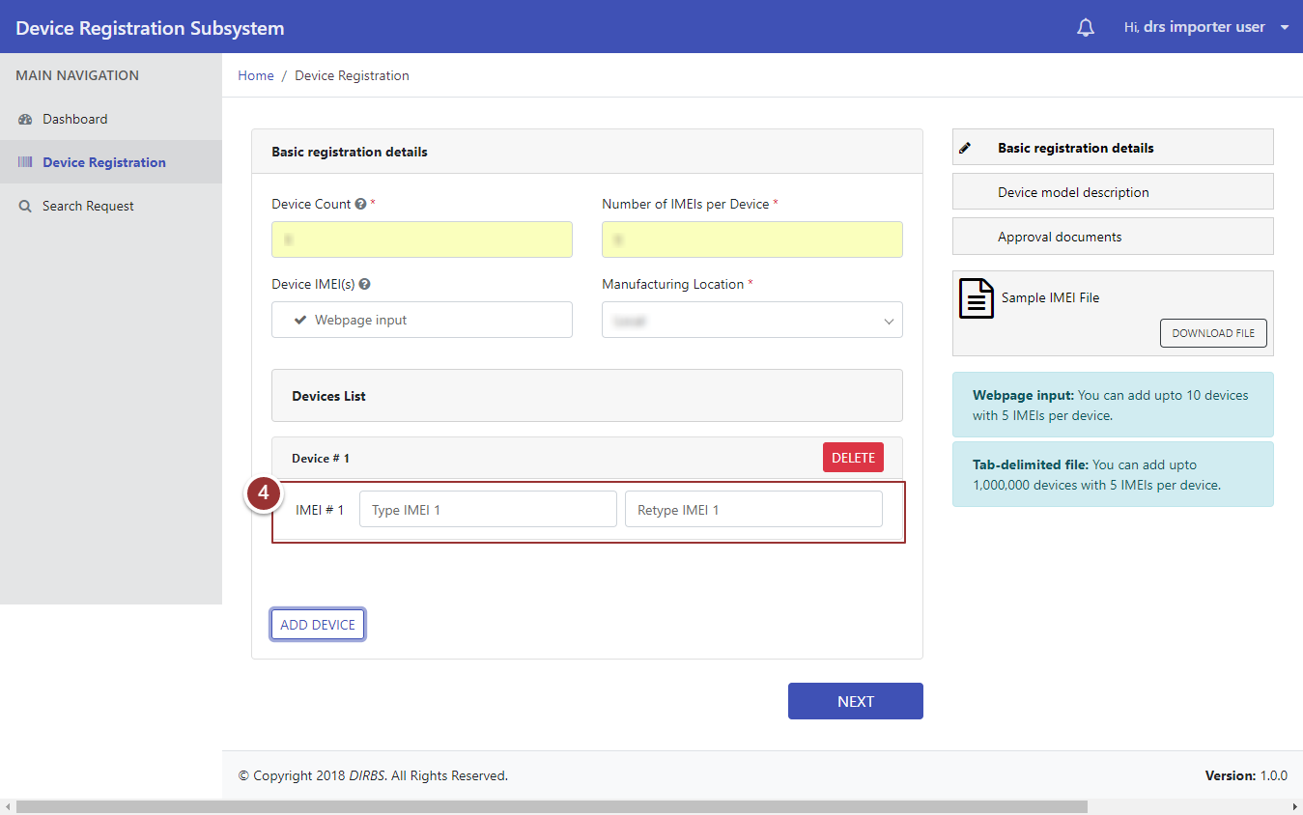

Figure 12 - Add Device (ii)

1. To delete entered IMEI, click on “Delete” button.

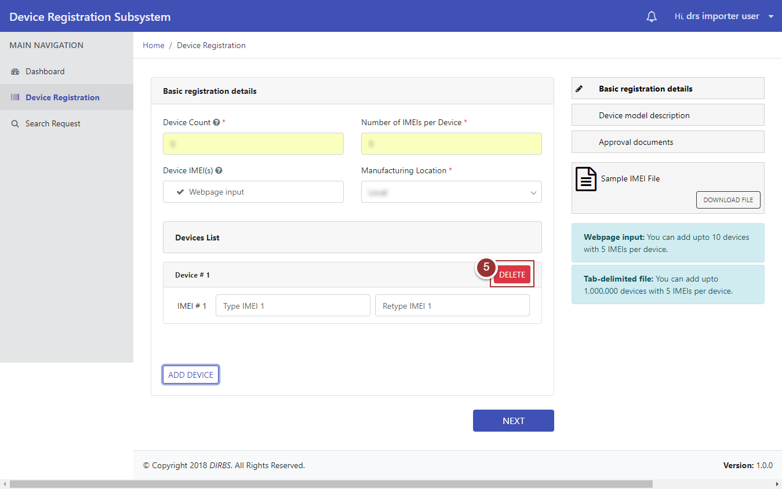

Figure 13 - Delete Device (i)

1. A popup will appear. Click on “OK” button for confirmation.

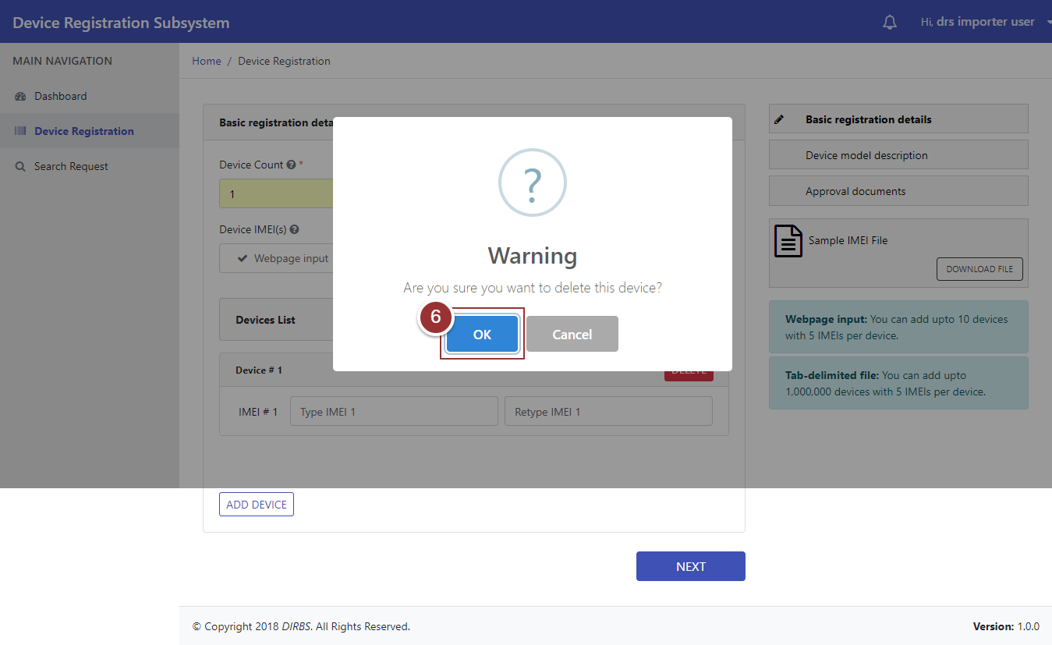

Figure 14 - Delete Device (ii)

1. Repeat the steps 3 and 4 to enter IMEI(s) again, then click on “Next” button.

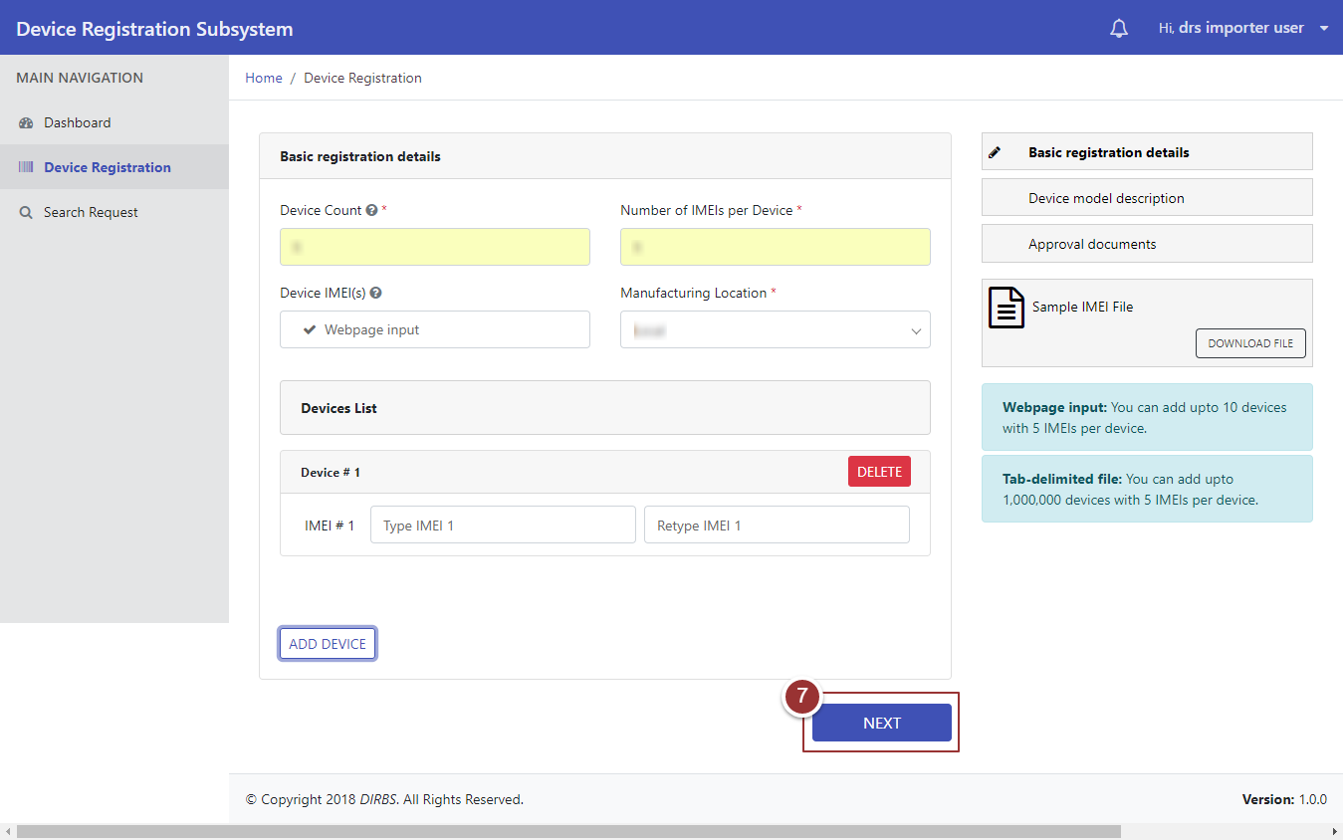

Figure 15 - Type IMEI

After clicking on “Next” button, user will be redirected to “Device Model Description” section.

1. Enter details of device model (i.e. Brand Name, Model Name, Model Number, Device Type, Operating System, and Radio Access Technology) in respective field(s).
2. To view previously entered details (i.e. Basic Registration Details), click on “Previous Details” tab.
3. Click on “Next” button.

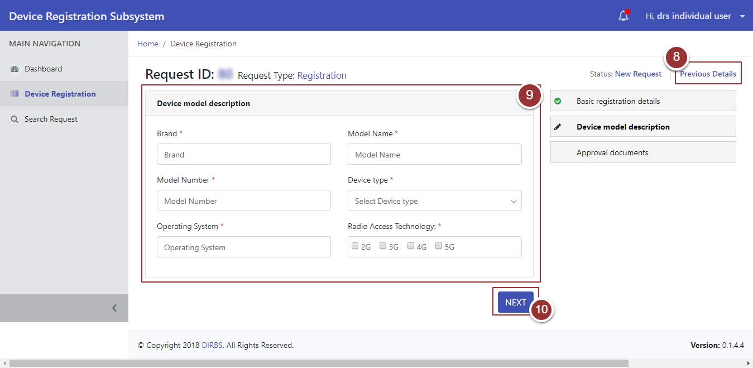

Figure 16 - Device Model Description

After clicking on “Next” button, user will be redirected to a page where he/she will upload approval documents i.e. Shipment Document, Authorization Document, and Certificate Document.

1. To upload file, click on “Choose File” button and select file containing required information.

**Note**: File should be inpre-defined format i.e. .pdf .jpeg .png .bmp.

1. To view previously entered details i.e. Basic Registration Details and Device Model Description, click on “Previous Details” tab.
2. Click on “Submit” Button.

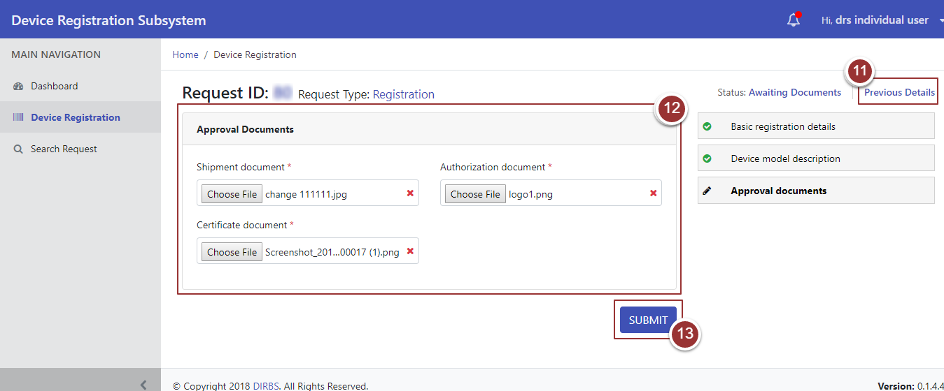

Figure 17 - Approval Documents

Upon request submission, a page will appear displaying the details i.e. Confirmation Message, Tracking ID, Status of the Request.

1. To view request, click on “View Your Request” button.

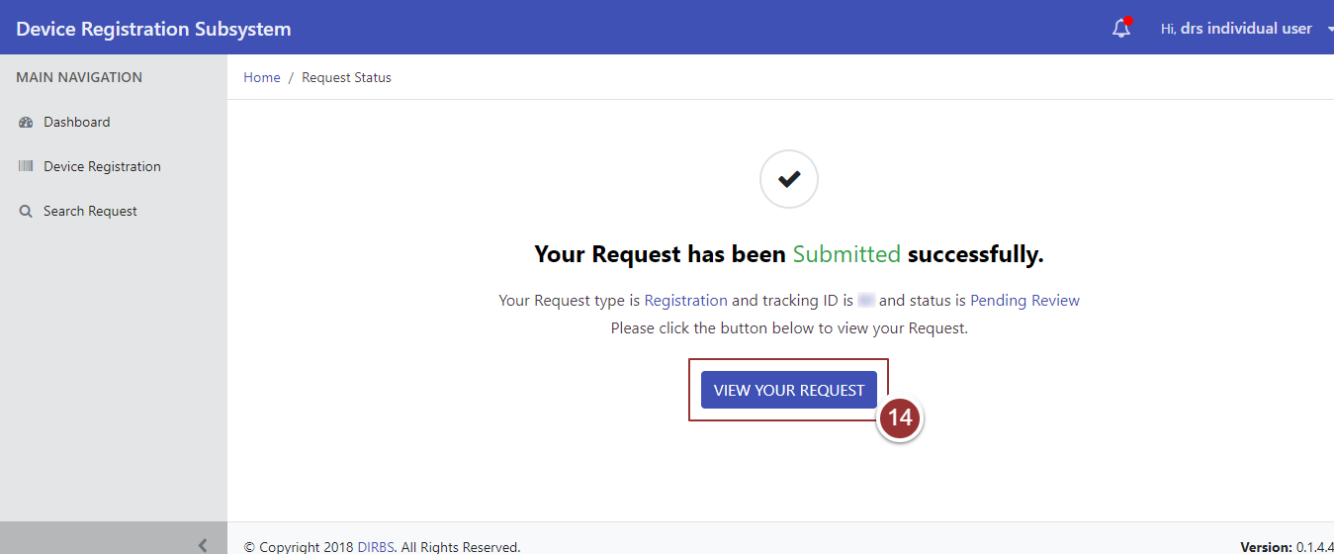

Figure 18 - Request Status

## **Device Registration (Automated Application Process)**

1. To request for device registration, click on “Device Registration” tab under “Main Navigation” heading.
2. Enter basic registration details i.e. Device Count, Number of IMEIs per Device, Device IMEIs and Manufacturing location.

**Note**: All field(s) are mandatory.

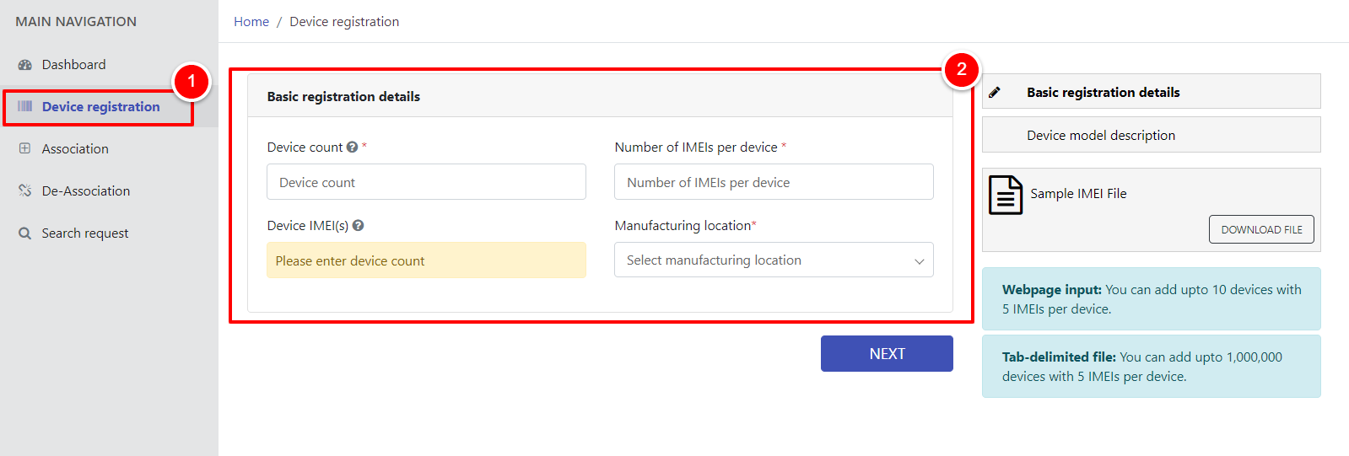

Figure 19 - Device Registration

1. To add IMEI of the device, click on “Add Device” button.

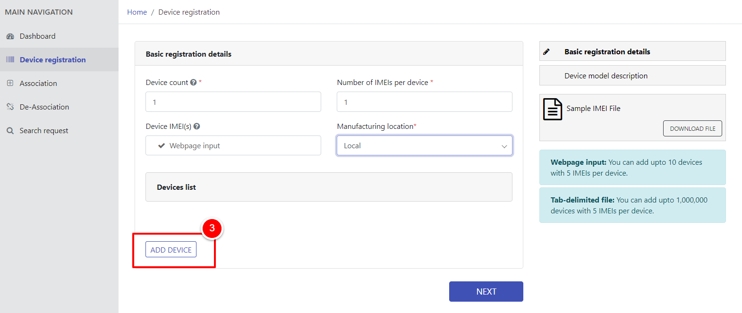

Figure 20 - Add Device (i)

1. Now, type and re-type IMEI in respective fields.

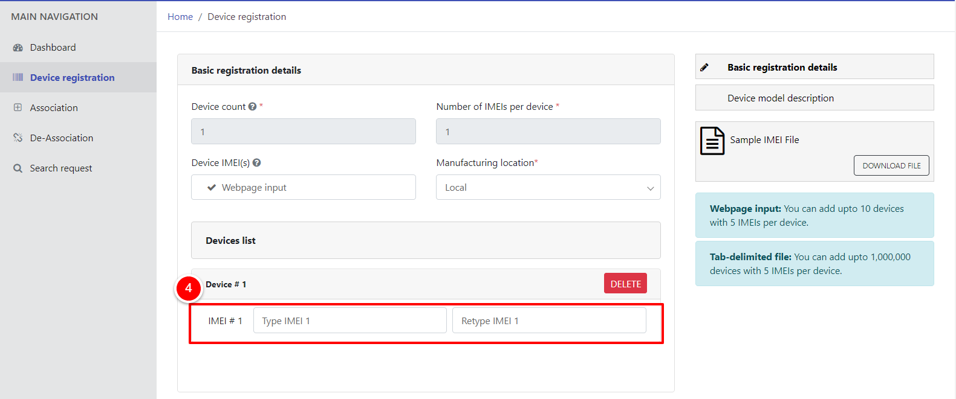

Figure 21 - Add Device (ii)

1. To delete entered IMEI, click on “Delete” button.

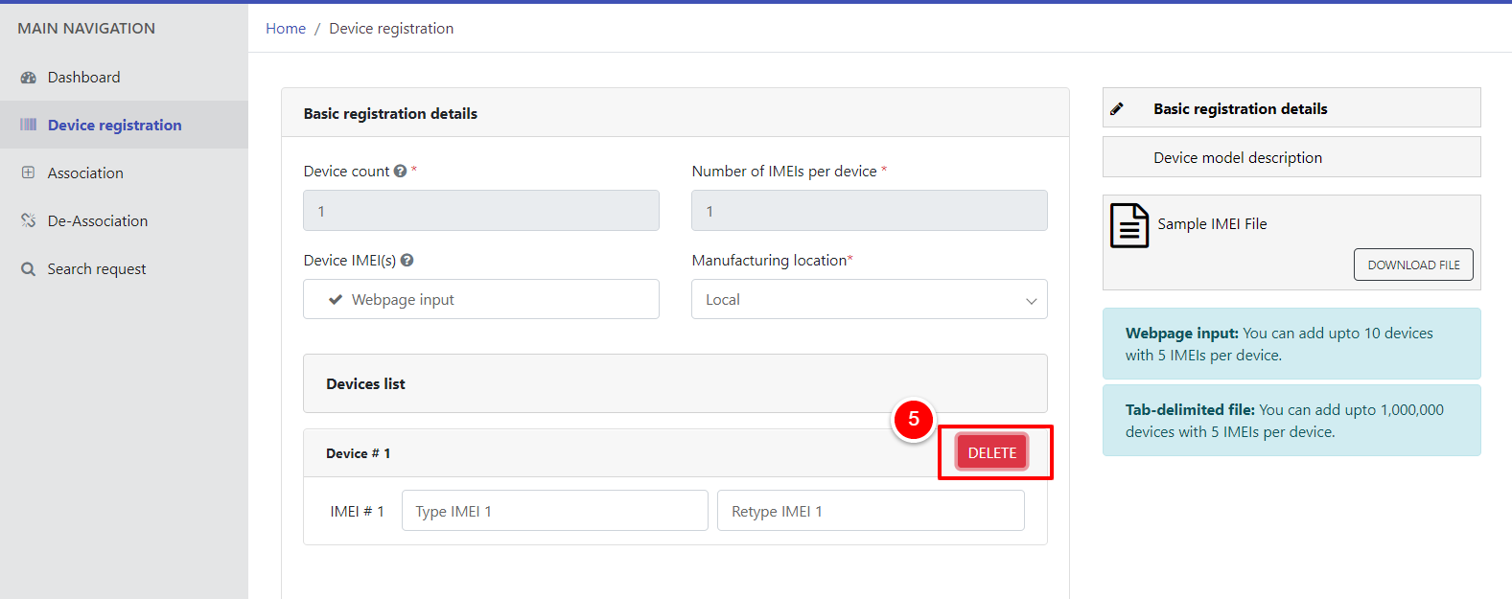

Figure 22 - Delete Device (i)

1. A popup will appear. Click on “OK” button for confirmation.

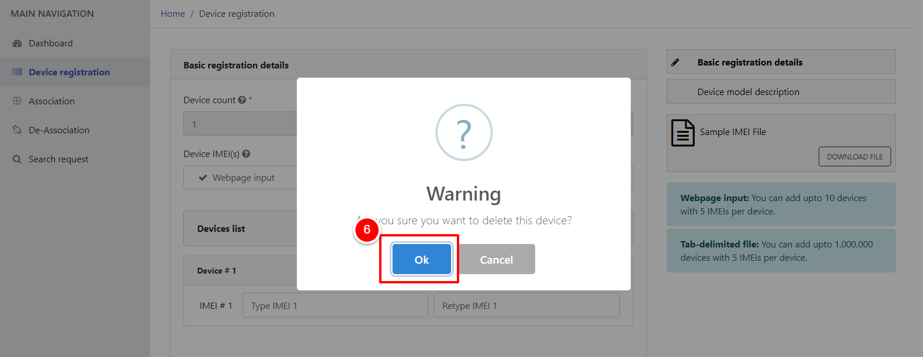

Figure 23 - Delete Device (ii)

1. Repeat the steps 3 and 4 to enter IMEI again, then click on “Next” button.

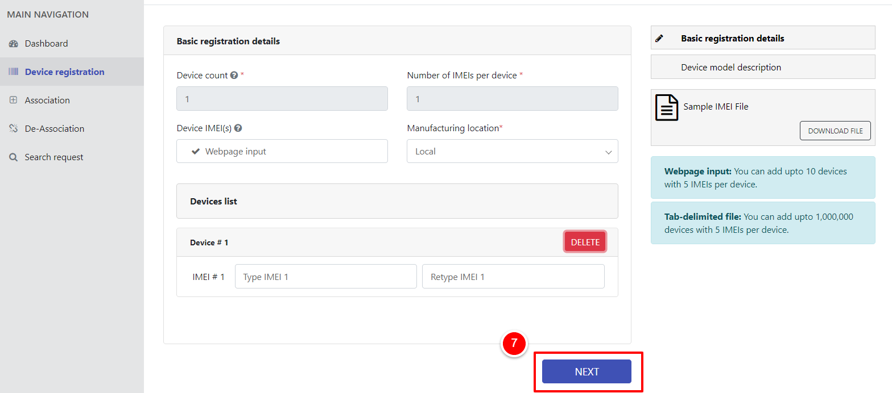

Figure 24 - Type IMEI

After clicking on “Next” button, user will be redirected to “Device Model Description” section.

1. Enter details of device model i.e. Brand Name, Model Name, Model Number, Device Type, Operating System, and Radio Access Technology in respective field(s).
2. To view previously entered details i.e. Basic Registration Details, click on “Previous Details” tab.
3. Click on “Finish” button.

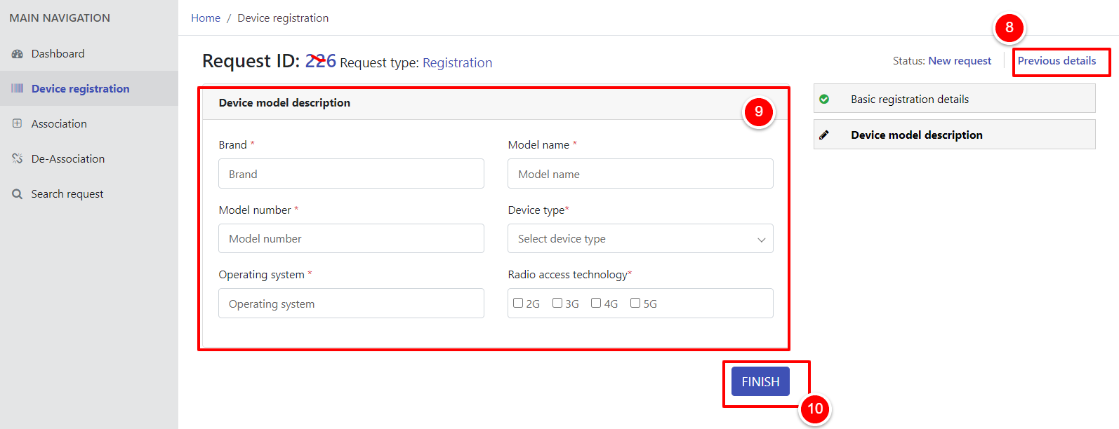

Figure 25 - Device Model Description

After clicking on “Finish” button, it will redirect submitted request with tracking ID.

Upon submission of request, a page will appear displaying the details i.e. Confirmation Message, Tracking ID.

1. To view request, click on “View Your Request” button.

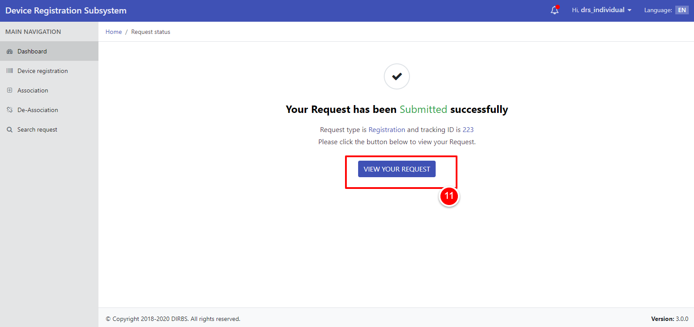

Figure 26 - Request Status

**Association**

1. To associate IMEI, click on “Association” tab.
2. Enter IMEI to be associated.
3. Click on “Associate” button.

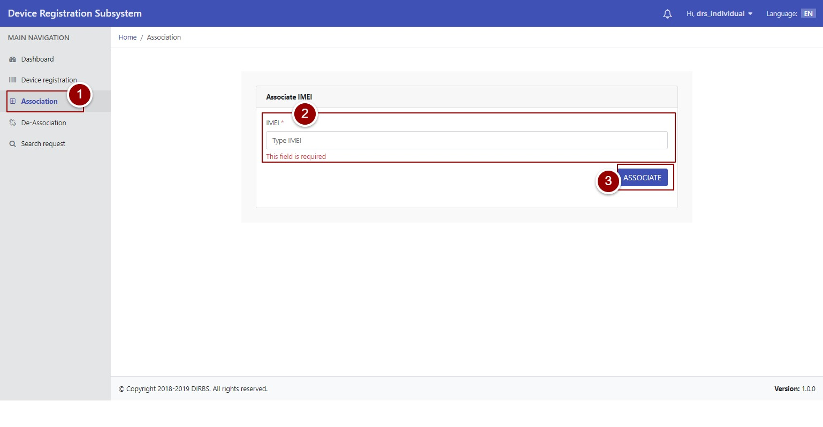

Figure 27 - IMEI Association (i)

1. A popup will appear for confirmation of IMEI association. Click on “Ok” button to confirm.

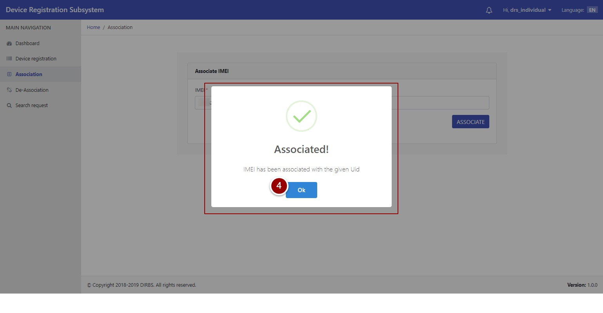

Figure 28 - IMEI Association (ii)

**De-Association**

1. To De-Associate IMEI, click on “De-Association” tab.
2. Click on “De-Associate IMEI” button against the required IMEI to be de-associated.

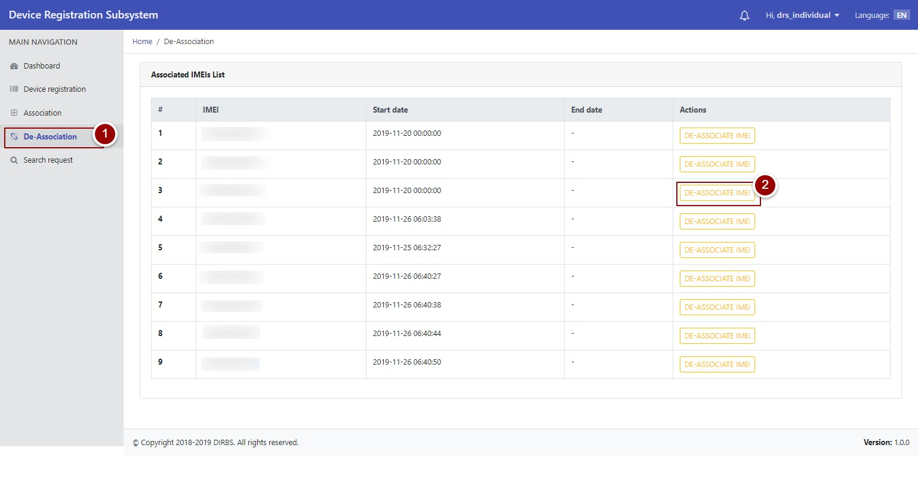

Figure 29 - IMEI De-Association (i)

1. A popup will appear for confirmation. Click on “Yes” button to confirm.

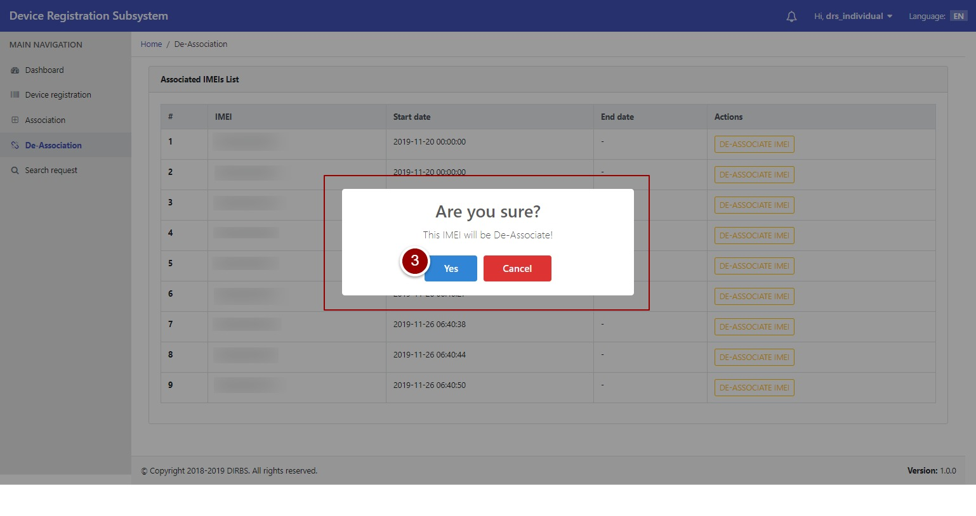

Figure 30 - IMEI De-Association (ii)

## **Search Request**

1. To search any request, click on “Search Request” tab.
2. To view all requests, click on “Search Requests” button.

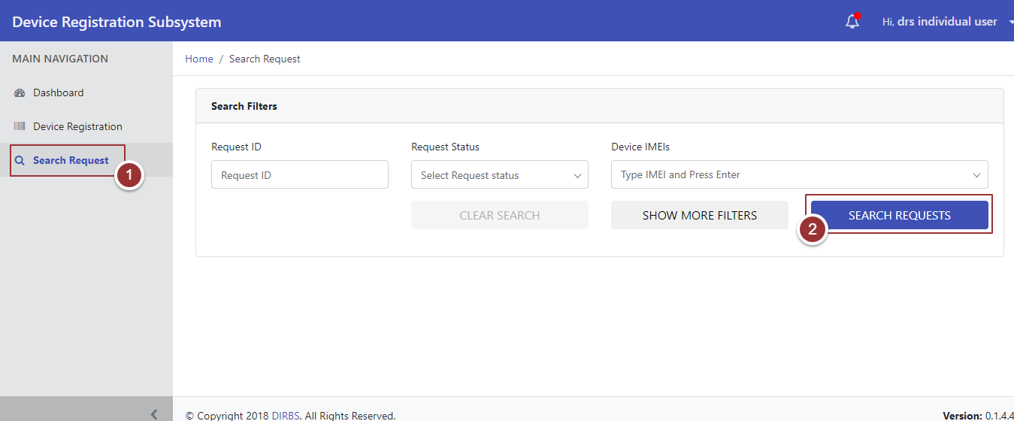

Figure 31 - Search Request(s)

By clicking on “Search Requests” button, system will display all requests that contain Request ID, Request Type, Device Count, Date Created, Date Last Updated, Request Status, and Actions. To manage number of found requests to be displayed on a page, click on drop-down menu “Show Requests” and select required number.

1. To update request, click on required action i.e. Complete, Modify, and Close.

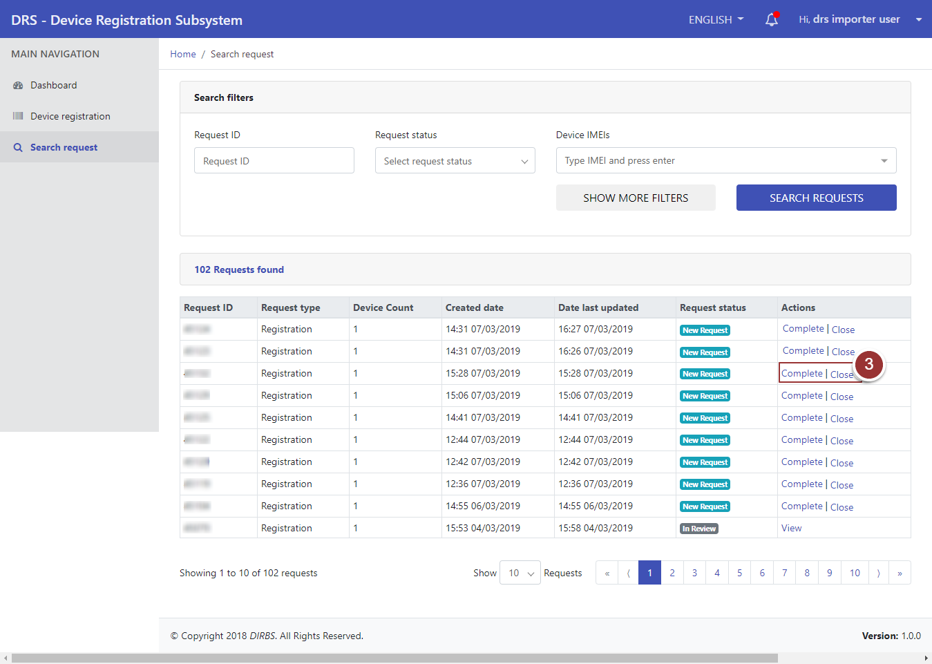

Figure 32 - Action Tab(s)

1. To view request, click on “View” link.

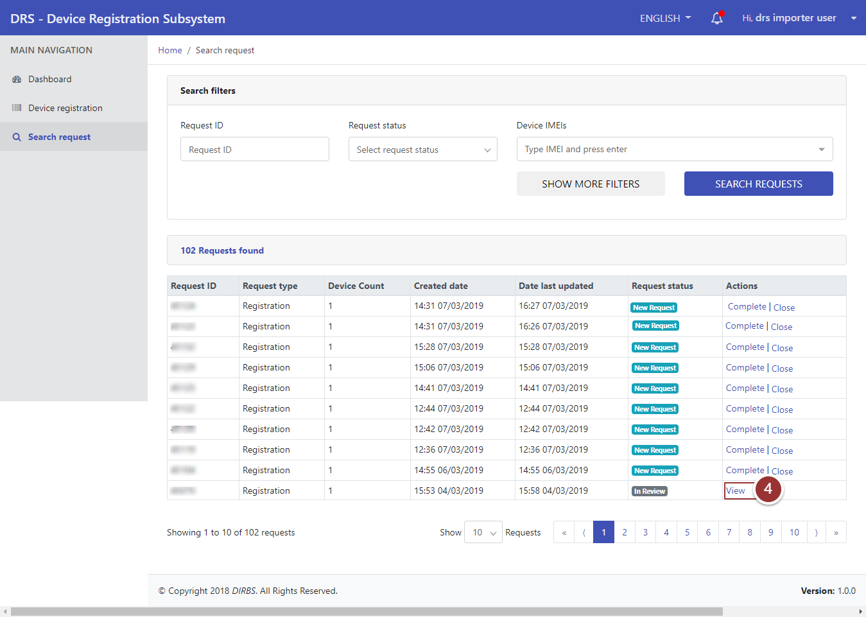

Figure 33 - View Request (i)

A page will appear that displays basic registration details of device.

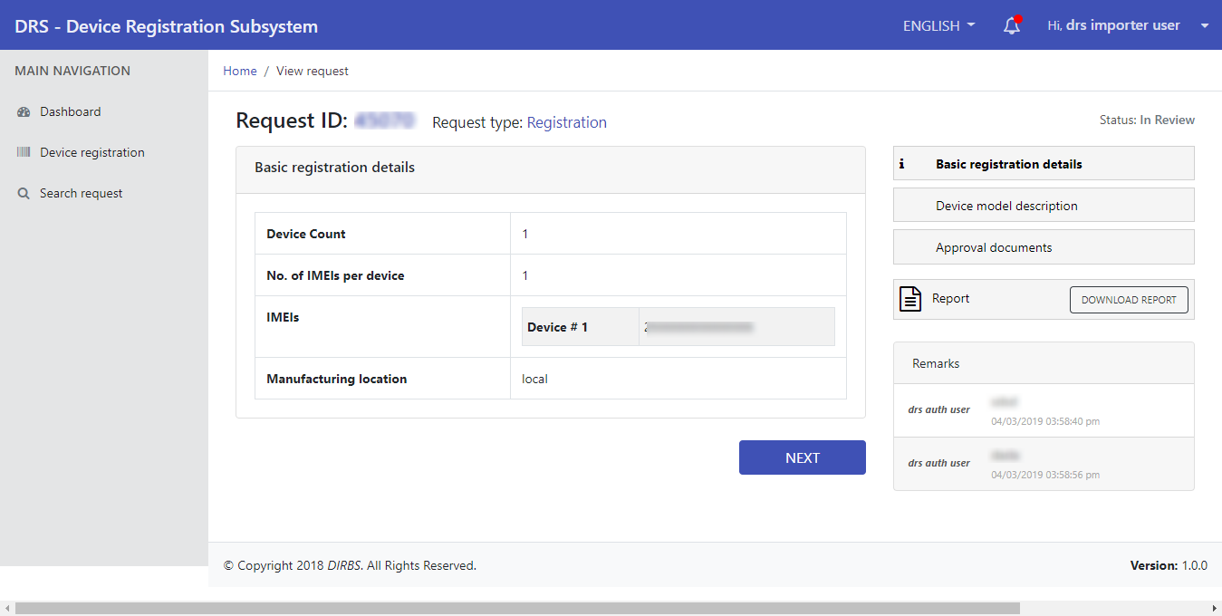

Figure 34 - View Request (ii)

1. To download report shared by reviewer, click on “Download Report” button.

**Note**: Download Report button will be visible when reviewer enables “Share Report with User” option.

1. To view other sections of request, click on “Next” button.

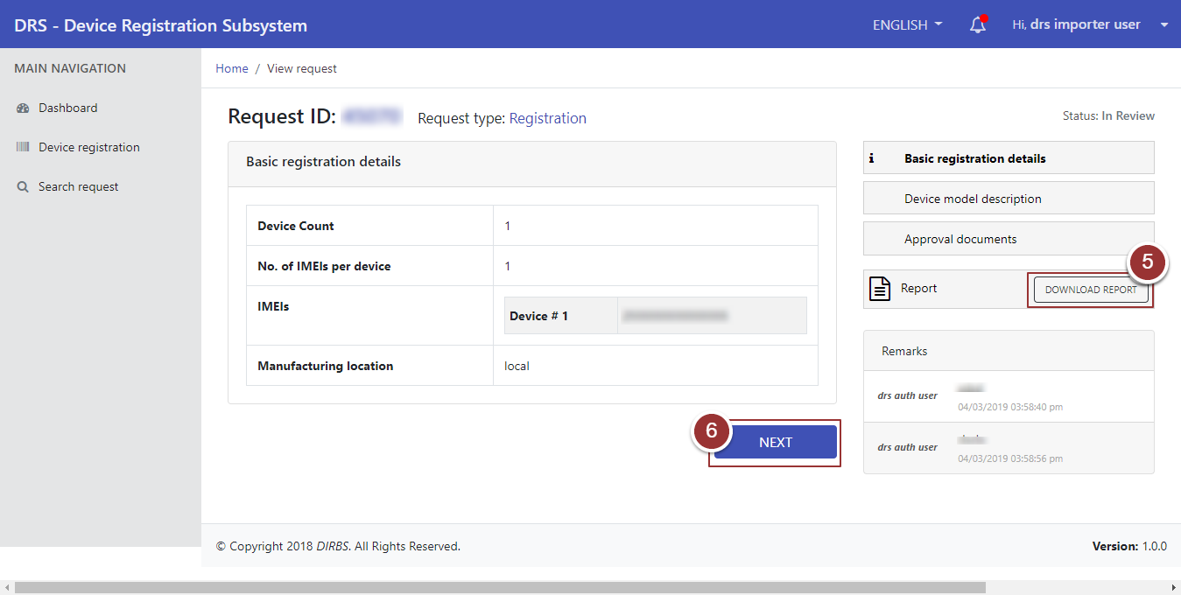

Figure 35 - Download Report Button

**Search Particular Request**

1. To search any particular request(s), click on “Search Request” tab.
2. Enter any known information about request i.e. Request ID, Request Status, Device IMEIs etc. For more search filters, click on “Show More Filters” button and enter known information related to the request.
3. Click on “Search Requests” button.

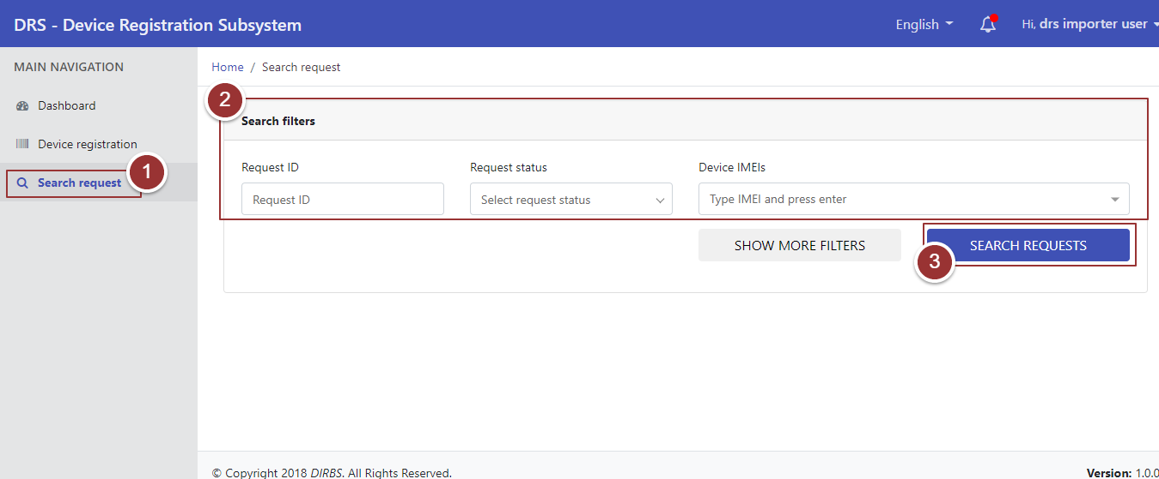

Figure 36 - Search Filters (i)

By clicking on “Search Requests” button, it will display request with applied search filters.

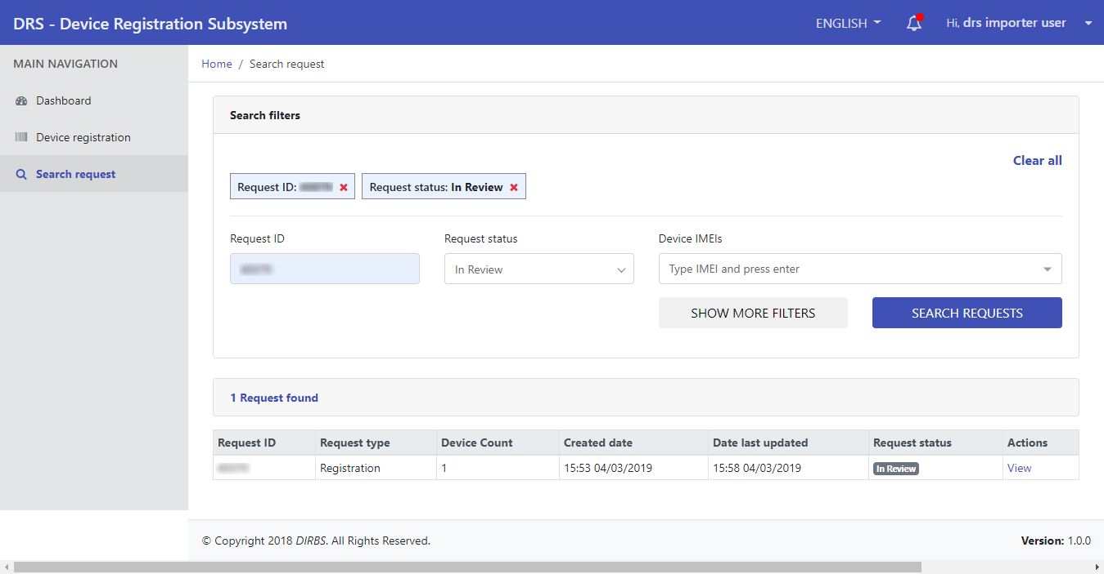

Figure 37 - Search Filters (ii)